Deep Learning Approaches in the Effects of Recession and FOMC Minutes on Oil Prices

ABSTRACT:
The financial industry is increasingly interested in predictive analysis and forecasting using time series data. Understanding the relationship between recessions and oil markets is crucial for developing f inancial forecasts and strategic decisions. This study uses advanced deep learning models to examine the interaction between recession signals and crude oil prices. Data covering recession periods include key economic indicators such as Gross Domestic Product (GDP) fluctuations, unemployment rates, consumer spending trends, business investments, and housing market dynamics. Additionally, Federal Open Market Committee (FOMC) minutes are used to capture economic assessments and monetary policy decisions by the Federal Reserve during recessions, providing insights into policymakers’ expectations and responses. Data is augmented using Time-series Generative Adversarial Networks (TimeGAN) to capture intricate patterns in oil prices. By focusing on feature selection, this study aims to identify patterns from historical data and relationships between recession signals and oil price movements. Long Short-Term Memory networks(LSTMs),GatedRecurrentUnits(GRUs),Transformer,andensemblelearningtechniquesareusedtopredict crude oil prices during recessions. This research provides insights into how recession signals and Federal Reserve policy decisions influence crude oil prices, offering a comprehensive view of the dynamics between economic downturns and the energy market.
TABLE OF CONTENTS
CHAPTER NO. | TITLE | PAGE NO.
 | ABSTRACT  LIST OF FIGURES  LIST OF SYMBOLS | i  v  vii
1. | CHAPTER 1 : INTRODUCTION  - GENERAL  - SCOPE OF THE PROJECT  - OBJECTIVE  1.4 EXISTING SYSTEM  1.4.1 EXISTINGSYSTEM DISADVANTAGES  1.5 LITERATURE SURVEY  1.6 PROPOSED SYSTEM  1.6.1 PROPOSED SYSTEM ADVANTAGES
2. | CHAPTER 2 :PROJECT DESCRIPTION  2.1 GENERAL  2.2 METHODOLOGIES  2.2.1 MODULES NAME  2.2.2 MODULES EXPLANATION  2.3 TECHNIQUE OR ALGORITHM
3. | CHAPTER 3 : REQUIREMENTS  3.1 General  3.2 Hardware REQUIREMENTS  3.3 Software REQUIREMENTS
4. | CHAPTER 4 :SYSTEM DESIGN  4.1 general  4.2 uml diagrams  4.2.1 USE CASE DIAGRAM  4.2.2 CLASS DIAGRAM  4.2.3 OBJECT DIAGRAM  4.2.4 STATE DIAGRAM  4.2.5 activity diagram  4.2.6 SEQUENCE DIAGRAM  4.2.7 COLLABORATION DIAGRAM  4.2.8 COMPONENT DIAGRAM  4.2.9 DATA FLOW DIAGRAM  4.2.10 DEPLOYMENT DIAGRAM  4.2.11 SYSTEM ARCHITECTURE
5. | CHAPTER 5 : DEVELOPMENT TOOLS  5.1 general  5.2 History of Python  5.3 Importance of Python  5.4 Features of Python  5.5 Libraries used in python
6. | CHAPTER 6 :IMPLEMENTATION  6.1 GENERAL  6.2 IMPLEMENTATION

7. | CHAPTER 7 :SNAPSHOTS  7.1 GENERAL  7.2 VARIOUS SNAPSHOTS
8. | CHAPTER 8 :SOFTWARE TESTING  8.1 GENERAL  8.2 DEVELOPING METHODOLOGIES  8.3 TYPES OF TESTING
9. | CHAPTER 9 :  FUTURE ENHANCEMENT  9.1 FUTURE ENHANCEMENTS
10 | CHAPTER 10 :  10.1CONCLUSION  10.2 REFERENCES

LIST OF FIGURES

FIGURE NO | NAME OF THE FIGURE | PAGE NO.
4.1 | Use case Diagram
4.2 | Class diagram
4.3 | Object diagram
4.4 | State Diagram
4.5 | Activity Diagram
4.6 | Sequence diagram
4.7 | Collaboration diagram
4.8 | Component Diagram
4.9 | Data flow diagram
4.10 | Deployment Diagram
4.11 | Architecture Diagram

LIST OF SYSMBOLS

S.NO | NOTATION  NAME | NOTATION | DESCRIPTION
1. | Class | Class Name  -attribute  -attribute  +operation  +operation  +operation  + public  -private  # protected | Represents a collection of similar entities grouped together.
2. | Association | name  Class B  Class A  Class A  Class B | Associations represents static relationships between classes. Roles represents the way the two classes see each other.
3. | Actor | Class A  Class A  Class B  Class B | It aggregates several classes into a single classes.
4. | Aggregation | Class A  Class A  Class B  Class B | Interaction between the system and external environment

5. | Relation  (uses) | uses | Used for additional process communication.
6. | Relation  (extends) | extends | Extends relationship is used when one use case is similar to another use case but does a bit more.
7. | Communication |  | Communication between various use cases.
8. | State | State | State of the processes.
9. | Initial State |  | Initial state of the object
10. | Final state |  | Final state of the object
11. | Control flow |  | Represents various control flow between the states.
12. | Decision box |  | Represents decision making process from a constraint
13. | Use case | Uses case | Interact ion between the system and external environment.
14. | Component |  | Represents physical modules which are a collection of components.
15. | Node |  | Represents physical modules which are a collection of components.
16. | Data Process/State |  | A circle in DFD represents a state or process which has been triggered due to some event or action.
17. | External entity |  | Represents external entities such as keyboard, sensors, etc.
18. | Transition |  | Represents communication that occurs between processes.
19. | Object Lifeline |  | Represents the vertical dimensions that the object communications.
20. | Message | Message | Represents the message exchanged.

CHAPTER-1
INTRODUCTION
The financial industry relies heavily on predictive analytics to anticipate market trends and make strategic decisions. One of the most critical areas of economic forecasting is understanding how recessions influence crude oil prices, as oil is a key driver of global economic activity. Sudden fluctuations in oil prices can impact inflation, production costs, and overall economic stability. Therefore, analyzing the relationship between economic downturns and oil market behavior is essential for policymakers, investors, and financial analysts. This study leverages deep learning techniques to analyze recession signals and their impact on crude oil price movements. By incorporating key economic indicators such as GDP fluctuations, unemployment rates, consumer spending, business investments, and housing market trends, the research aims to uncover hidden patterns in time series data. Additionally, insights from the Federal Open Market Committee (FOMC) minutes are integrated to understand how monetary policy decisions influence oil prices during economic downturns. To enhance predictive accuracy, the study employs Long Short-Term Memory networks (LSTMs), Gated Recurrent Units (GRUs), Transformers, and ensemble learning models. Moreover, Time-series Generative Adversarial Networks (TimeGAN) are used to generate synthetic data, capturing complex dependencies in oil price movements during recessions. By leveraging advanced deep learning architectures and feature selection techniques, this research provides valuable insights into the dynamic relationship between recessions and crude oil prices, enabling more accurate financial forecasting and strategic decision-making.
1.2 SCOPE OF THE PROJECT
The scope of this project is centered on analyzing and predicting crude oil price movements during economic recessions using advanced deep learning models. The study aims to bridge the gap between financial forecasting and deep learning methodologies by incorporating a range of economic indicators such as GDP fluctuations, unemployment rates, consumer spending trends, and housing market performance. Additionally, Federal Open Market Committee (FOMC) minutes are included to capture the influence of monetary policies on oil price trends. A key focus of the project is to enhance the accuracy of oil price predictions during recessions by leveraging deep learning architectures such as Long Short-Term Memory networks (LSTMs), Gated Recurrent Units (GRUs), Transformers, and ensemble learning techniques. To further refine predictions, Time-series Generative Adversarial Networks (TimeGAN) are employed to generate synthetic data that preserves intricate dependencies in time series patterns. The project aims to provide financial analysts, investors, and policymakers with a reliable forecasting model that aids in economic decision-making and risk management during periods of economic downturn.
1.3 OBJECTIVE
The primary objective of this project is to develop a robust predictive model that accurately forecasts crude oil price movements during recessions by utilizing deep learning techniques. By analyzing historical economic data, the study seeks to uncover hidden patterns and relationships between recession indicators and oil market fluctuations. Another key objective is to improve feature selection techniques by identifying the most influential economic indicators that drive changes in oil prices. This helps in refining the input data for deep learning models and enhances predictive performance. Furthermore, the study aims to incorporate explainable AI techniques to ensure transparency in model predictions, enabling stakeholders to understand how economic factors influence oil price trends. Ultimately, the project aspires to contribute to the field of financial forecasting by providing a data-driven approach to understanding how recessions impact the energy market. By integrating deep learning with macroeconomic analysis, the study aims to deliver valuable insights for investors, policymakers, and financial institutions, facilitating informed decision-making in volatile economic conditions.
1.4 EXISTING SYSTEM:
The existing financial forecasting systems primarily rely on traditional econometric models and statistical techniques such as Autoregressive Integrated Moving Average (ARIMA) and Vector Autoregression (VAR). These models analyze historical trends in economic indicators like GDP, unemployment rates, and consumer spending to make predictions about market behavior, including crude oil prices. However, they struggle to capture the intricate, nonlinear dependencies between multiple economic factors and sudden market fluctuations during recessions. Additionally, existing models often fail to incorporate qualitative data such as Federal Reserve assessments, limiting their predictive accuracy.
Another limitation of the existing system is its inability to handle large-scale unstructured data efficiently. Conventional forecasting techniques are largely dependent on pre-defined mathematical functions and linear assumptions, which make them less effective in identifying complex temporal patterns in financial and energy markets. Due to these constraints, current forecasting models lack robustness when dealing with volatile periods such as economic recessions, leading to inaccurate predictions and suboptimal decision-making.
1.4.1 EXISTING SYSTEM DISADVANTAGES:
- Limited ability to capture non-linear relationships
- Reliance on stationarity assumptions
- Difficulty handling high-dimensional, multi-variable datasets
- Inability to incorporate qualitative policy data
- Reduced adaptability during volatile economic conditions

1.5 LITERATURE SURVEY
Title: Predicting stock market index using LSTM
Author: Hum Nath Bhandari, Binod Rimal, Nawa Raj Pokhrel, Ramchandra Rimal, Keshab R. Dahal, Rajendra K.C. Khatri
Year: 2022
Description: The rapid advancement in artificial intelligence and machine learning techniques, availability of large-scale data, and increased computational capabilities of the machine opens the door to develop sophisticated methods in predicting stock price. In the meantime, easy access to investment opportunities has made the stock market more complex and volatile than ever. The world is looking for an accurate and reliable predictive model which can capture the market’s highly volatile and nonlinear behavior in a holistic framework. This study uses a long short-term memory (LSTM), a particular neural network architecture, to predict the next-day closing price of the S&P 500 index. A well-balanced combination of nine predictors is carefully constructed under the umbrella of the fundamental market data, macroeconomic data, and technical indicators to capture the behavior of the stock market in a broader sense. Single layer and multilayer LSTM models are developed using the chosen input variables, and their performances are compared using standard assessment metrics–Root Mean Square Error (RMSE), Mean Absolute Percentage Error (MAPE), and Correlation Coefficient (R). The experimental results show that the single layer LSTM model provides a superior fit and high prediction accuracy compared to multilayer LSTM models.

Title: Real-time Visual Inspection System for Grading Fruits using Computer Vision and Deep Learning Techniques
Author: Sahar Erfanian, Yewang Zhou,Amar Razzaq, Asif Ali Safeer andTeng Li
Year: 2022.
Description: Bitcoin (BTC)—the first cryptocurrency—is a decentralized network used to make private, anonymous, peer-to-peer transactions worldwide, yet there are numerous issues in its pricing due to its arbitrary nature, thus limiting its use due to skepticism among businesses and households. However, there is a vast scope of machine learning approaches to predict future prices precisely. One of the major problems with previous research on BTC price predictions is that they are primarily empirical research lacking sufficient analytical support to back up the claims. Therefore, this study aims to solve the BTC price prediction problem in the context of both macroeconomic and microeconomic theories by applying new machine learning methods. Previous work, however, shows mixed evidence of the superiority of machine learning over statistical analysis and vice versa, so more research is needed. This paper applies comparative approaches, including ordinary least squares (OLS), Ensemble learning, support vector regression (SVR), and multilayer perceptron (MLP), to investigate whether the macroeconomic, microeconomic, technical, and blockchain indicators based on economic theories predict the BTC price or not. The findings point out that some technical indicators are significant short-run BTC price predictors, thus confirming the validity of technical analysis. Moreover, macroeconomic and blockchain indicators are found to be significant long-term predictors, implying that supply, demand, and cost-based pricing theories are the underlying theories of BTC price prediction. Likewise, SVR is found to be superior to other machine learning and traditional models. This research’s innovation is looking at BTC price prediction through theoretical aspects. The overall findings show that SVR is superior to other machine learning models and traditional models. This paper has several contributions. It can contribute to international finance to be used as a reference for setting asset pricing and improved investment decision-making. It also contributes to the economics of BTC price prediction by introducing its theoretical background. Moreover, as the authors still doubt whether machine learning can beat the traditional methods in BTC price prediction, this research contributes to machine learning configuration and helping developers use it as a benchmark.
Title: Time series forecasting using ensemble learning methods for emergency prevention in hydroelectric power plants with dam
Author: Stefenon, Stéfano Frizzo, Ribeiro, Matheus Henrique Dal Molin, Nied, Ademir, Yow, Kin-Choong ; Mariani, Viviana Cocco
Year: 2023.
Description: In hydroelectric plants, the responsibility for the operation of the reservoirs typically lies with the national system operator, who controls the level of the reservoirs based on a stochastic problem for the economy of the potential energy available in the reservoir. However, in an emergency, the responsibility for the operation and control of the reservoir becomes the plant's management. To have a faster decision-making process, it is important to have a forecast of water affluence in relation to the turbine capacity and use of the spillway. With the objective of evaluating the forecast increase in the level of the reservoir of a hydroelectric plant, this paper compares the use of the bagging, boosting, random subspace, bagging plus random subspace, and stacked generalization ensemble learning models to analyze this problem. The case study is based on data from a 690 MW hydroelectric plant, which has a 94 km reservoir and a 185 m high dam. The random subspace and stacking models had the best results for lower error, with a low time required for convergence in relation to the other models. The ensemble models resulted in greater accuracy for the assessed problem than long short-term memory.

Title: A comprehensive review on ensemble deep learning: : Opportunities and challenges
Author: Ammar Mohammed, Rania Kora
Year: 2023
Description: In machine learning, two approaches outperform traditional algorithms: ensemble learning and deep learning. The former refers to methods that integrate multiple base models in the same framework to obtain a stronger model that outperforms them. The success of an ensemble method depends on several factors, including how the baseline models are trained and how they are combined. In the literature, there are common approaches to building an ensemble model successfully applied in several domains. On the other hand, deep learning-based models have improved the predictive accuracy of machine learning across a wide range of domains. Despite the diversity of deep learning architectures and their ability to deal with complex problems and the ability to extract features automatically, the main challenge in deep learning is that it requires a lot of expertise and experience to tune the optimal hyper-parameters, which makes it a tedious and time-consuming task. Numerous recent research efforts have been made to approach ensemble learning to deep learning to overcome this challenge. Most of these efforts focus on simple ensemble methods that have some limitations. Hence, this review paper provides comprehensive reviews of the various strategies for ensemble learning, especially in the case of deep learning. Also, it explains in detail the various features or factors that influence the success of ensemble methods. In addition, it presents and accurately categorized several research efforts that used ensemble learning in a wide range of domains.

Title: The Power of Text-based Indicators in Forecasting the Italian Economic Activity
Author: Valentina Aprigliano, Simone Emiliozzi, Gabriele Guaitoli, Andrea Luciani, Juri Marcucci, Libero Monteforte
Year: 2023.
Description: We produce a set of high-frequency text-based sentiment and policy uncertainty indicators (TESI and TEPU respectively), which are constantly updated, not revised and computed both for the whole economy and for specific sectors or economic topics. To test the predictive power of our text-based indicators, we propose two forecasting exercises. First, by using Bayesian Model Averaging (BMA) techniques, we show that our monthly text-based indicators greatly reduce the uncertainty surrounding the short-term forecasts of the main macroeconomic aggregates, especially during recessions. Secondly, we employ these indices in a weekly GDP growth tracker, achieving sizeable gains in forecasting accuracy in both normal and turbulent times.

1.6 PROPOSED SYSTEM
The proposed system leverages advanced deep learning techniques to enhance the accuracy of crude oil price forecasting during recessions. By integrating Long Short-Term Memory (LSTM) networks, Gated Recurrent Units (GRUs), Transformers, and ensemble learning, the model captures intricate relationships between economic indicators and oil price fluctuations. Unlike traditional models, this approach can dynamically learn from sequential data, adapting to changes in market trends over time. Additionally, the inclusion of Time-series Generative Adversarial Networks (TimeGAN) allows for data augmentation, improving the model’s ability to generalize across various economic conditions.
Furthermore, the proposed system incorporates textual analysis of Federal Open Market Committee (FOMC) minutes to gain insights into policymakers’ economic assessments. This multimodal approach enhances the ability to predict how recession signals and monetary policy decisions influence crude oil prices. By integrating deep learning and natural language processing techniques, this system provides a more comprehensive and adaptable forecasting framework, ensuring better strategic decision-making in the financial sector.
1.6.1 PROPOSED SYSTEM ADVANTAGES:
- Superior modeling of complex, non-linear relationships
- Enhanced processing of multi-dimensional datasets with deep learning
- Integration of qualitative data (e.g., FOMC minutes)
- Robust performance during periods of market volatility
- Improved prediction accuracy through ensemble deep learning techniques
CHAPTER 2
PROJECT DESCRIPTION
2.1 GENERAL:
This project explores the relationship between economic recessions and crude oil price fluctuations using advanced deep learning models. Traditional methods of forecasting oil prices often rely on statistical approaches that may fail to capture complex economic patterns and dependencies. To address this limitation, this study utilizes Long Short-Term Memory (LSTM) networks, Gated Recurrent Units (GRUs), Transformers, and ensemble learning techniques to develop a more accurate and robust prediction model. The dataset used in this study includes historical economic indicators such as GDP fluctuations, unemployment rates, consumer spending trends, business investments, and housing market dynamics. Additionally, the project incorporates Federal Open Market Committee (FOMC) minutes, which provide insights into monetary policies and economic outlooks during recessions. To enhance data representation and model performance, Time-series Generative Adversarial Networks (TimeGAN) are employed for data augmentation, ensuring the model captures intricate patterns in oil price movements. The project follows a structured methodology, starting with data preprocessing, feature selection, and normalization to ensure data quality. It then proceeds with model training and optimization, where deep learning techniques are applied to analyze trends and predict oil price fluctuations. The final stage involves evaluating model performance using metrics such as Mean Squared Error (MSE), Root Mean Squared Error (RMSE), and Mean Absolute Error (MAE).By integrating deep learning models with macroeconomic analysis, this project provides a data-driven approach to oil price forecasting, helping investors, policymakers, and financial institutions make informed decisions. The study also explores the impact of economic downturns on the energy market, offering valuable insights for strategic planning and risk management in the financial sector.

2.2 METHODOLOGIES
2.2.1MODULES NAME:
Modules Name:
- Extracting Data
- Making Sense of Data
- Structuring Information
- Operating the model
- Correcting Deviations
- Analytical Precision
- Inferring Consequences

    - MODULES EXPLANATION:
Extracting Data:
The study collects historical economic data, including recession indicators such as GDP fluctuations, unemployment rates, consumer spending trends, and business investments. Additionally, it incorporates crude oil price movements and Federal Open Market Committee (FOMC) minutes. These datasets provide a comprehensive foundation for understanding the interaction between economic downturns and oil markets. The data is sourced from reliable financial institutions and government reports to ensure accuracy.
Making Sense of Data:
To understand the relationship between recessions and oil prices, the study applies exploratory data analysis (EDA). Trends, correlations, and anomalies are identified within the dataset to gain deeper insights. Feature selection techniques help in extracting the most relevant economic indicators for analysis. The goal is to highlight key recession signals that impact crude oil price fluctuations.

Structuring Information:
The dataset is preprocessed by handling missing values, normalizing numerical variables, and encoding categorical information where necessary. Time-series data is structured in a way that captures historical trends and dependencies. Feature engineering techniques help refine the dataset for better predictive accuracy. Proper structuring ensures that the deep learning models can effectively learn complex patterns.
Operating the Model:
The study employs advanced deep learning models, including Long Short-Term Memory (LSTM), Gated Recurrent Units (GRU), Transformers, and ensemble learning methods. These models analyze time-series data to predict oil price movements during recessions. The integration of Time-Series Generative Adversarial Networks (TimeGAN) enhances data augmentation and model training. The models are trained using optimized hyperparameters to improve forecasting precision.
Correcting Deviations:
Performance evaluation is conducted using metrics like Mean Absolute Error (MAE) and Root Mean Square Error (RMSE). Any deviations in predictions are addressed by fine-tuning the models and adjusting learning rates. Regularization techniques help prevent overfitting and ensure generalization. Cross-validation methods are applied to enhance model robustness.
Analytical Precision:
The effectiveness of the predictive models is validated by comparing results across different architectures. Feature importance analysis helps determine which economic indicators have the most significant impact on crude oil prices. Model interpretability techniques, such as SHAP (Shapley Additive Explanations), provide transparency in decision-making. This ensures that the insights derived from the model are reliable and actionable.

Inferring Consequences:
The study provides critical insights into how recession signals and Federal Reserve policies influence crude oil prices. Policymakers, financial analysts, and energy market stakeholders can leverage these predictions for strategic decision-making. The findings contribute to a deeper understanding of economic downturns and their impact on global energy markets. Ultimately, the research helps in developing more accurate financial forecasting models.

2.3 TECHNIQUE USED OR ALGORITHM USED
2.3.1 EXISTING TECHNIQUE:
ARIMA is a widely used statistical forecasting algorithm for time series analysis. It combines autoregression (AR), differencing (I), and moving average (MA) components to model time-dependent relationships in financial data. The AR component predicts future values based on past observations, the I component stabilizes the series by removing trends, and the MA component accounts for past forecast errors to improve accuracy. However, ARIMA is limited in capturing complex nonlinear relationships in financial markets, especially during economic downturns. It assumes stationarity, meaning the underlying statistical properties of the data remain constant over time, which is often not the case in highly volatile markets like crude oil. Additionally, ARIMA struggles with high-dimensional, multi-variable datasets, making it less effective for modeling economic indicators alongside oil price movements.
2.3.2 PROPOSED TECHNIQUE USED OR ALGORITHM USED:
LSTM is a type of recurrent neural network (RNN) designed to address the vanishing gradient problem in sequential data modeling. It introduces memory cells with input, forget, and output gates that regulate the flow of information over time, allowing the model to retain long-term dependencies. This makes LSTM particularly effective for financial forecasting, where past economic trends influence future market behavior. In the proposed system, LSTMs are used to analyze historical oil prices and recession signals, learning complex dependencies that traditional models fail to capture. By incorporating additional deep learning techniques such as GRUs and Transformers, the system enhances predictive performance. The integration of TimeGAN further enriches the dataset, ensuring the model learns from a more diverse range of economic scenarios. This combination results in a robust forecasting framework capable of predicting oil price fluctuations with high accuracy during recessions.
CHAPTER 3
REQUIREMENTS ENGINEERING
3.1 GENERAL
We can see from the results that on each database, the error rates are very low due to the discriminatory power of features and the regression capabilities of classifiers. Comparing the highest accuracies (corresponding to the lowest error rates) to those of previous works, our results are very competitive.

3.2 HARDWARE REQUIREMENTS
The hardware requirements may serve as the basis for a contract for the implementation of the system and should therefore be a complete and consistent specification of the whole system. They are used by software engineers as the starting point for the system design. It should what the system do and not how it should be implemented.

- PROCESSOR : DUAL CORE 2 DUOS.
- RAM : 4GB DD RAM
- HARD DISK : 500 GB

3.3 SOFTWARE REQUIREMENTS
The software requirements document is the specification of the system. It should include both a definition and a specification of requirements. It is a set of what the system should do rather than how it should do it. The software requirements provide a basis for creating the software requirements specification. It is useful in estimating cost, planning team activities, performing tasks and tracking the teams and tracking the team’s progress throughout the development activity.
- Operating System : Windows 10
- Platform : Spyder3
- Programming Language : Python
- Front End : Spyder3

3.4 FUNCTIONAL REQUIREMENTS
A functional requirement defines a function of a software-system or its component. A function is described as a set of inputs, the behavior, Firstly, the system is the first that achieves the standard notion of semantic security for data confidentiality in attribute-based deduplication systems by resorting to the hybrid cloud architecture.

3.5 NON-FUNCTIONAL REQUIREMENTS
The major non-functional Requirements of the system are as follows
Usability
The system is designed with completely automated process hence there is no or less user intervention.
Reliability
The system is more reliable because of the qualities that are inherited from the chosen platform python. The code built by using python is more reliable.
Performance
This system is developing in the high level languages and using the advanced back-end technologies it will give response to the end user on client system with in very less time.
Supportability
The system is designed to be the cross platform supportable. The system is supported on a wide range of hardware and any software platform, which is built into the system.
Implementation
The system is implemented in web environment using Jupyter notebook software. The server is used as the intellignce server and windows 10 professional is used as the platform. Interface the user interface is based on Jupyter notebook provides server system.

CHAPTER 4
DESIGN ENGINEERING
4.1 GENERAL
Design Engineering deals with the various UML [Unified Modelling language] diagrams for the implementation of project. Design is a meaningful engineering representation of a thing that is to be built. Software design is a process through which the requirements are translated into representation of the software. Design is the place where quality is rendered in software engineering.

4.2 UML DIAGRAMS
4.2.1 USE CASE DIAGRAM
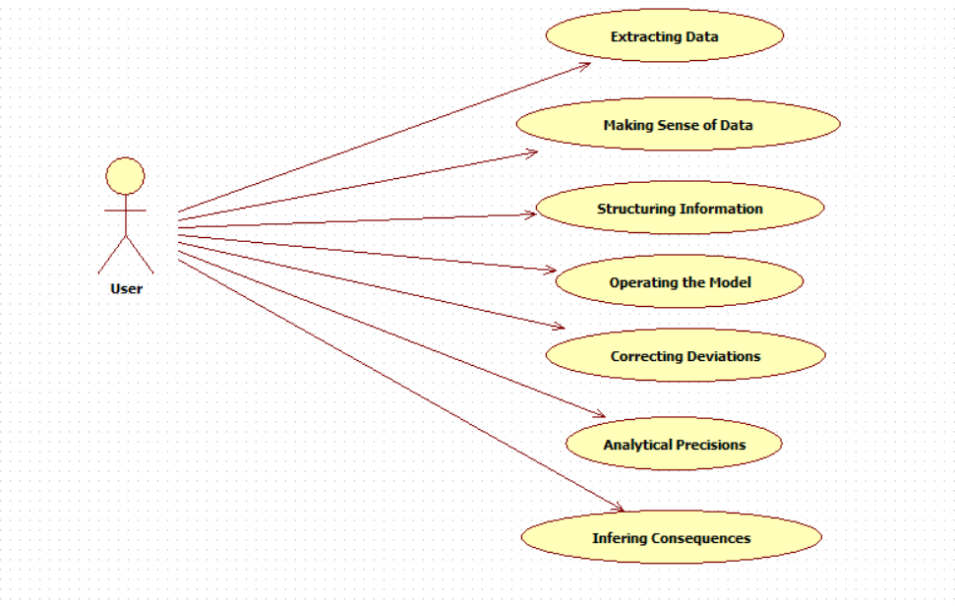
EXPLANATION:
The main purpose of a use case diagram is to show what system functions are performed for which actor. Roles of the actors in the system can be depicted. The above diagram consists of user as actor. Each will play a certain role to achieve the concept.
4.2.2 CLASS DIAGRAM
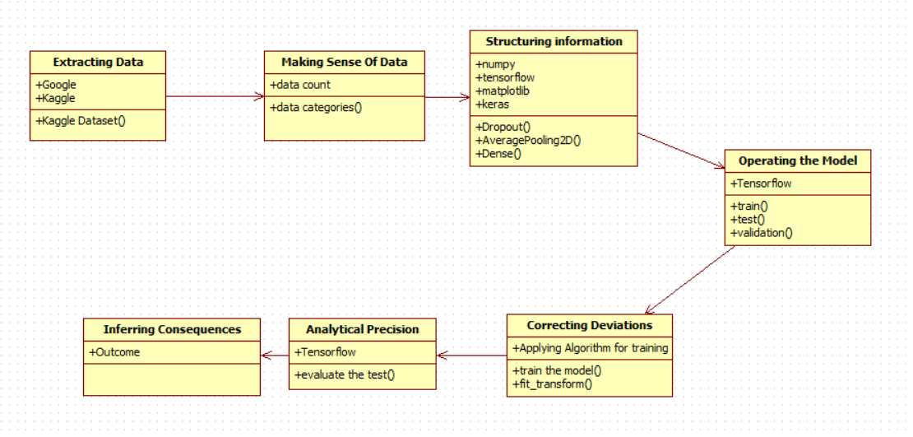
EXPLANATION
In this class diagram represents how the classes with attributes and methods are linked together to perform the verification with security. From the above diagram shown the various classes involved in our project.

4.2.3 OBJECT DIAGRAM
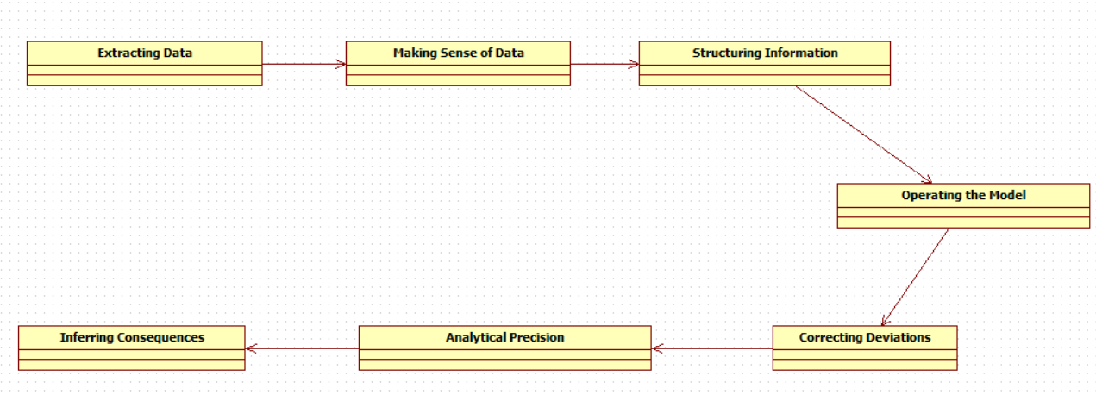
EXPLANATION:
In the above digram tells about the flow of objects between the classes. It is a diagram that shows a complete or partial view of the structure of a modeled system. In this object diagram represents how the classes with attributes and methods are linked together to perform the verification with security.

4.2.4 STATE DIAGRAM
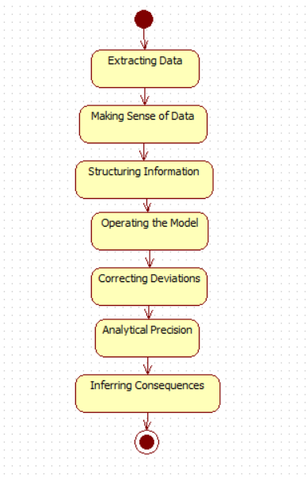

EXPLANATION:
State diagram are a loosely defined diagram to show workflows of stepwise activities and actions, with support for choice, iteration and concurrency. State diagrams require that the system described is composed of a finite number of states; sometimes, this is indeed the case, while at other times this is a reasonable abstraction. Many forms of state diagrams exist, which differ slightly and have different semantics.
4.2.5 ACTIVITY DIAGRAM
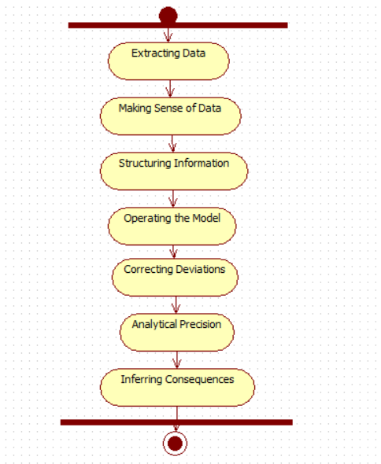
EXPLANATION:
Activity diagrams are graphical representations of workflows of stepwise activities and actions with support for choice, iteration and concurrency. In the Unified Modeling Language, activity diagrams can be used to describe the business and operational step-by-step workflows of components in a system. An activity diagram shows the overall flow of control.

4.2.6 SEQUENCE DIAGRAM
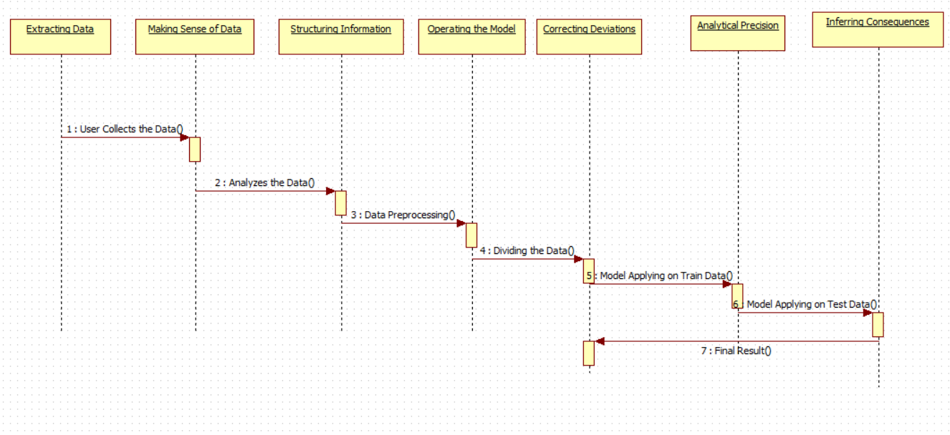
EXPLANATION:
A sequence diagram in Unified Modeling Language (UML) is a kind of interaction diagram that shows how processes operate with one another and in what order. It is a construct of a Message Sequence Chart. A sequence diagram shows object interactions arranged in time sequence. It depicts the objects and classes involved in the scenario and the sequence of messages exchanged between the objects needed to carry out the functionality of the scenario.

4.2.7 COLLABORATION DIAGRAM
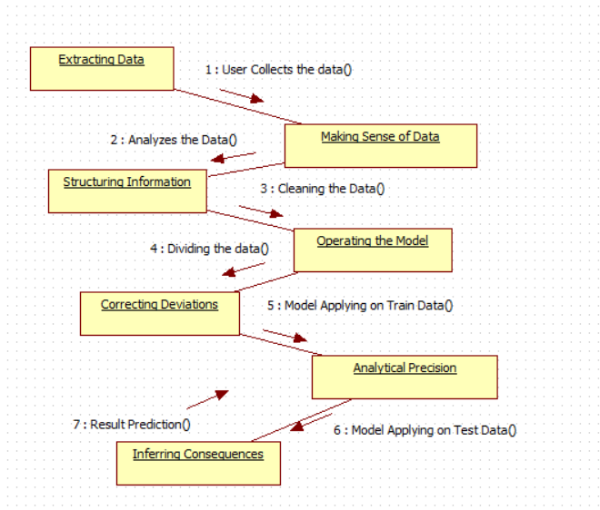
EXPLANATION:
A collaboration diagram, also called a communication diagram or interaction diagram, is an illustration of the relationships and interactions among software objects in the Unified Modeling Language (UML). The concept is more than a decade old although it has been refined as modeling paradigms have evolved.

4.2.8 COMPONENT DIAGRAM
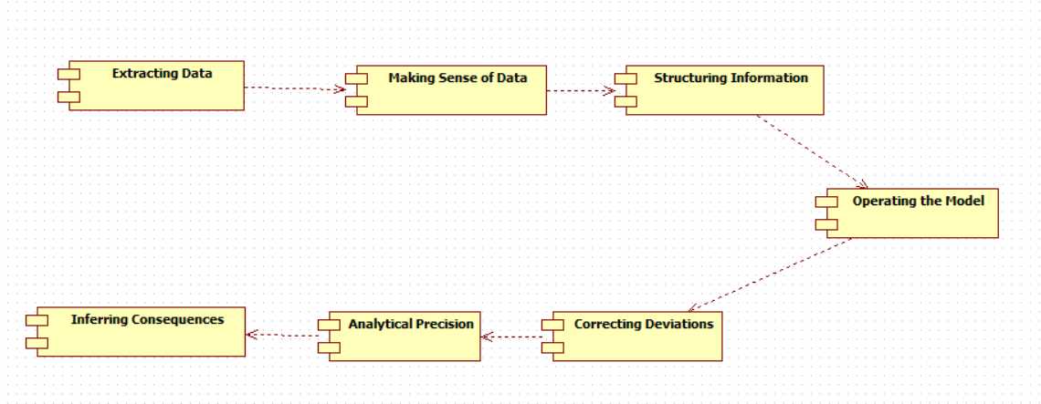
EXPLANATION

In the Unified Modeling Language, a component diagram depicts how components are wired together to form larger components and or software systems. They are used to illustrate the structure of arbitrarily complex systems. User gives main query and it converted into sub queries and sends through data dissemination to data aggregators. Results are to be showed to user by data aggregators. All boxes are components and arrow indicates dependencies.

4.2.9 DATA FLOW DIAGRAM
Level 0
Structing Information
User
Extracting Data
Making Sense of Data

Level 1
Inferring Consequences
Operating the Model
Correcting Deviations
Analytical Precision

Fig 4.9: Data Flow Diagrams
EXPLANATION:
A data flow diagram (DFD) is a graphical representation of the "flow" of data through an information system, modeling its process aspects. Often they are a preliminary step used to create an overview of the system which can later be elaborated. DFDs can also be used for the visualization of data processing (structured design).
A DFD shows what kinds of data will be input to and output from the system, where the data will come from and go to, and where the data will be stored. It does not show information about the timing of processes, or information about whether processes will operate in sequence or in parallel.

4.2.10 DEPLOYMENT DIAGRAM
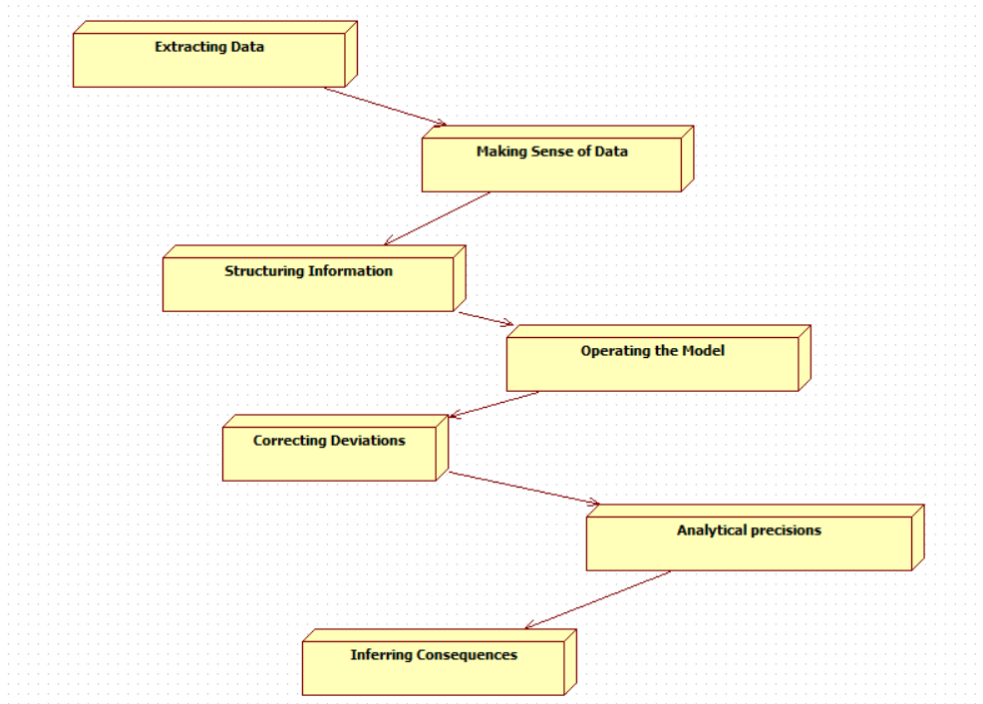
EXPLANATION:
Deployment Diagram is a type of diagram that specifies the physical hardware on which the software system will execute. It also determines how the software is deployed on the underlying hardware. It maps software pieces of a system to the device that are going to execute it.

SYSTEM ARCHITECTURE:

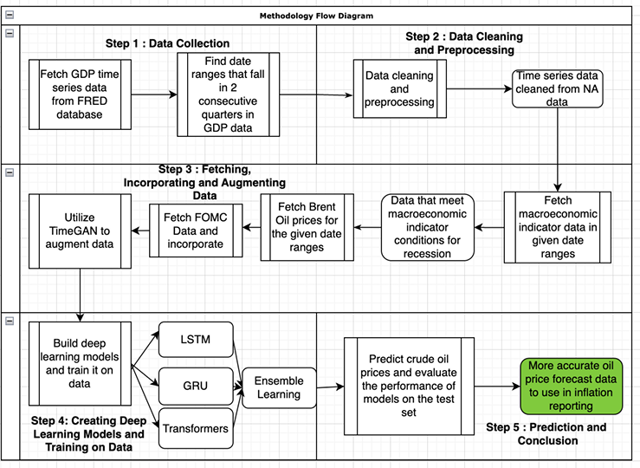

Fig 4.11: System Architecture

CHAPTER 5
DEVELOPMENT TOOLS
5.1 Python
Python is a high-level, interpreted, interactive and object-oriented scripting language. Python is designed to be highly readable. It uses English keywords frequently where as other languages use punctuation, and it has fewer syntactical constructions than other languages.

5.2 History of Python
Python was developed by Guido van Rossum in the late eighties and early nineties at the National Research Institute for Mathematics and Computer Science in the Netherlands.
Python is derived from many other languages, including ABC, Modula-3, C, C++, Algol-68, SmallTalk, and Unix shell and other scripting languages.
Python is copyrighted. Like Perl, Python source code is now available under the GNU General Public License (GPL).
Python is now maintained by a core development team at the institute, although Guido van Rossum still holds a vital role in directing its progress.

5.3 Importance of Python
- Python is Interpreted − Python is processed at runtime by the interpreter. You do not need to compile your program before executing it. This is similar to PERL and PHP.
- Python is Interactive − You can actually sit at a Python prompt and interact with the interpreter directly to write your programs.
- Python is Object-Oriented − Python supports Object-Oriented style or technique of programming that encapsulates code within objects.
- Python is a Beginner's Language − Python is a great language for the beginner-level programmers and supports the development of a wide range of applications from simple text processing to WWW browsers to games.

5.4 Features of Python
- Easy-to-learn − Python has few keywords, simple structure, and a clearly defined syntax. This allows the student to pick up the language quickly.
- Easy-to-read − Python code is more clearly defined and visible to the eyes.
- Easy-to-maintain − Python's source code is fairly easy-to-maintain.
- A broad standard library − Python's bulk of the library is very portable and cross-platform compatible on UNIX, Windows, and Macintosh.
- Interactive Mode − Python has support for an interactive mode which allows interactive testing and debugging of snippets of code.
- Portable − Python can run on a wide variety of hardware platforms and has the same interface on all platforms.
- Extendable − You can add low-level modules to the Python interpreter. These modules enable programmers to add to or customize their tools to be more efficient.
- Databases − Python provides interfaces to all major commercial databases.
- GUI Programming − Python supports GUI applications that can be created and ported to many system calls, libraries and windows systems, such as Windows MFC, Macintosh, and the X Window system of Unix.
- Scalable − Python provides a better structure and support for large programs than shell scripting.

Apart from the above-mentioned features, Python has a big list of good features, few are listed below −
- It supports functional and structured programming methods as well as OOP.
- It can be used as a scripting language or can be compiled to byte-code for building large applications.
- It provides very high-level dynamic data types and supports dynamic type checking.
- IT supports automatic garbage collection.
- It can be easily integrated with C, C++, COM, ActiveX, CORBA, and Java.
5.5 Libraries used in python
- numpy - mainly useful for its N-dimensional array objects.
- pandas - Python data analysis library, including structures such as dataframes.
- matplotlib - 2D plotting library producing publication quality figures.
- scikit-learn - the machine learning algorithms used for data analysis and data mining tasks.
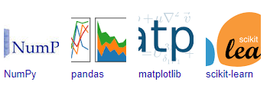
Figure : NumPy, Pandas, Matplotlib, Scikit-learn

CHAPTER 6
IMPLEMENTATION
6.1 GENERAL
Coding:

CHAPTER 7
SNAPSHOTS
General:
This project is implements like application using python and the Server process is maintained using the SOCKET & SERVERSOCKET and the Design part is played by Cascading Style Sheet.

SNAPSHOTS

CHAPTER 8
SOFTWARE TESTING

8.1 GENERAL
The purpose of testing is to discover errors. Testing is the process of trying to discover every conceivable fault or weakness in a work product. It provides a way to check the functionality of components, sub assemblies, assemblies and/or a finished product It is the process of exercising software with the intent of ensuring that the Software system meets its requirements and user expectations and does not fail in an unacceptable manner. There are various types of test. Each test type addresses a specific testing requirement.

8.2 DEVELOPING METHODOLOGIES
The test process is initiated by developing a comprehensive plan to test the general functionality and special features on a variety of platform combinations. Strict quality control procedures are used. The process verifies that the application meets the requirements specified in the system requirements document and is bug free. The following are the considerations used to develop the framework from developing the testing methodologies.

8.3Types of Tests

8.3.1 Unit testing
Unit testing involves the design of test cases that validate that the internal program logic is functioning properly, and that program input produce valid outputs. All decision branches and internal code flow should be validated. It is the testing of individual software units of the application .it is done after the completion of an individual unit before integration. This is a structural testing, that relies on knowledge of its construction and is invasive. Unit tests perform basic tests at component level and test a specific business process, application, and/or system configuration. Unit tests ensure that each unique path of a business process performs accurately to the documented specifications and contains clearly defined inputs and expected results.

8.3.2 Functional test
Functional tests provide systematic demonstrations that functions tested are available as specified by the business and technical requirements, system documentation, and user manuals.
Functional testing is centered on the following items:
Valid Input : identified classes of valid input must be accepted.
Invalid Input : identified classes of invalid input must be rejected.
Functions : identified functions must be exercised.
Output : identified classes of application outputs must be exercised.
Systems/Procedures: interfacing systems or procedures must be invoked.

8.3.3 System Test
System testing ensures that the entire integrated software system meets requirements. It tests a configuration to ensure known and predictable results. An example of system testing is the configuration oriented system integration test. System testing is based on process descriptions and flows, emphasizing pre-driven process links and integration points.

8.3.4 Performance Test
The Performance test ensures that the output be produced within the time limits,and the time taken by the system for compiling, giving response to the users and request being send to the system for to retrieve the results.

8.3.5 Integration Testing
Software integration testing is the incremental integration testing of two or more integrated software components on a single platform to produce failures caused by interface defects.
The task of the integration test is to check that components or software applications, e.g. components in a software system or – one step up – software applications at the company level – interact without error.

8.3.6 Acceptance Testing
User Acceptance Testing is a critical phase of any project and requires significant participation by the end user. It also ensures that the system meets the functional requirements.

Acceptance testing for Data Synchronization:
- The Acknowledgements will be received by the Sender Node after the Packets are received by the Destination Node
- The Route add operation is done only when there is a Route request in need
- The Status of Nodes information is done automatically in the Cache Updation process

8.2.7 Build the test plan

Any project can be divided into units that can be further performed for detailed processing. Then a testing strategy for each of this unit is carried out. Unit testing helps to identity the possible bugs in the individual component, so the component that has bugs can be identified and can be rectified from errors.

CHAPTER 9
FUTURE ENHANCEMENT
9.1 FUTURE ENHANCEMENTS:
Future enhancements of this study can focus on integrating additional macroeconomic indicators, such as geopolitical events, inflation rates, and global trade policies, to improve the accuracy of crude oil price predictions during recessions. The use of advanced hybrid models combining deep learning with reinforcement learning could enhance predictive performance. Additionally, expanding the dataset to include real-time financial data streams can make the model more adaptive to sudden economic changes. Improving interpretability through more sophisticated Explainable AI (XAI) techniques will also help policymakers and analysts better understand the impact of various economic factors on oil prices.

CHAPTER 10
CONCLUSIONAND REFERENCES
10.1 CONCLUSION
This study provides a comprehensive analysis of the relationship between economic recessions and crude oil prices using advanced deep learning models. By incorporating key recession indicators, Federal Reserve policy decisions, and enhanced time-series data augmentation techniques, the research effectively captures complex market dynamics. The proposed approach improves forecasting accuracy, offering valuable insights for financial analysts, policymakers, and energy market stakeholders. The findings contribute to a better understanding of economic downturns, enabling more informed decision-making in financial forecasting and strategic planning.
10.2 REFERENCES
[1] H. N. Bhandari, B. Rimal, N. R. Pokhrel, R. Rimal, K. R. Dahal, and R. K. C. Khatri, ‘‘Predicting stock market index using LSTM,’’ Machine Learning with Applications, vol. 9, 2022. [2] J. Kavinnilaa, E. Hemalatha, J. Minu, and R. Dhanalakshmi, ‘‘Stock Price Prediction Based on LSTM Deep Learning Model,’’ in Proc. Int. Conf. System, Computation,AutomationandNetworking(ICSCAN),Puducherry, India, 2021, pp. 30-31.
[3] P. Massimo, F. Barcellona, and R. L. D’ecclesia, ‘‘Forecasting energy commodity prices using neural networks,’’ Advances in Decision Sciences, vol. 2012, 2012.
[4] M. A. Al-Shabi, ‘‘Credit Card Fraud Detection Using Autoencoder Model in Unbalanced Datasets,’’ Journal of Advances in Mathematics and Com puter Science, vol. 33, pp. 1–16, 2019. [5] S. Erfanian, Y. Zhou, A. Razzaq, A. Abbas, A. A. Safeer, and T. Li, ‘‘Predicting Bitcoin (BTC) Price in the Context of Economic Theories: AMachine Learning Approach,’’ Entropy, vol. 24, no. 10, p. 1487, 2022. DOI: 10.3390/e24101487.
[6] S. F. Stefenon, M. H. D. M. Ribeiro, A. Nied, K. C. Yow, V. C. Mariani, L. D. S. Coelho, and L. O. Seman, ‘‘Time series forecasting using ensemble learning methods for emergency prevention in hydroelectric power plants with dam,’’ Electric Power Systems Research, vol. 202, 2022.
[7] C. Wang, Z. Xiao, F. S. Zhao, D. Ni, and L. Li, ‘‘Research on Economic Recession Prediction Model From the Multiple Behavioral Features Per spective,’’ IEEE Access, vol. 7, pp. 83363–83371, 2019.
[8] Y. Kurihara and A. Fukushine, ‘‘AR Model or Machine Learning for Fore casting GDP and Consumer Price for G7 Countries,’’ Applied Economics and Finance, vol. 6, 2019.
[9] G. Cicceri, G. Inserra, and M. Limosani, ‘‘A Machine Learning Approach to Forecast Economic Recessions—An Italian Case Study,’’ Mathematics, vol. 8, no. 2, p. 241, 2020. DOI: 10.3390/math8020241.
[10] V. Ülke, A. Sahin, and A. Subasi, ‘‘A comparison of time series and machinelearning modelsforinflation forecasting: empirical evidence from the USA,’’ Neural Comput & Applic, vol. 30, pp. 1519–1527, 2018. DOI: 10.1007/s00521-016-2766-x.

[11] H. Ben Ameur, S. Boubaker, Z. Ftiti, W. Louhichi, and K. Tissaoui, ‘‘Forecasting commodity prices: empirical evidence using deep learning tools,’’ Annals of Operations Research, vol. 339, pp. 349–367, 2024.
[12] R. C. Tadle, ‘‘FOMC minutes sentiments and their impact on financial markets,’’ Journal of Economics and Business, vol. 118, 2022.
[13] T. H. Nguyen, K. Shirai, and J. Velcin, ‘‘Sentiment Analysis on Social MediaforStockMovementPrediction,’’ Expert Systems with Applications, vol. 42, pp. 9603–9611, 2015.
[14] A. Karabaş and B. Diri, ‘‘Irony Detection with Deep Learning in Turk ish Microblogs,’’ 2020 28th Signal Processing and Communications Ap plications Conference (SIU), Gaziantep, Turkey, 2020, pp. 1-4. DOI: 10.1109/SIU49456.2020.9302253.
[15] E. Kalamara, A. Turrell, C. Redl, G. Kapetanios, and S. Kapadia, ‘‘Mak ing text count: Economic forecasting using newspaper text,’’ Journal of Applied Econometrics, vol. 37, pp. 896-919, 2022.
[16] V. Aprigliano, S. Emiliozzi, G. Guaitoli, A. Luciani, J. Marcucci, and L. Monteforte, ‘‘The power of text-based indicators in forecasting Italian economic activity,’’ International Journal of Forecasting, vol. 39, pp. 791 808, 2023.
[17] E. Brophy, Z. Wang, Q. She, and T. Ward, ‘‘Generative Adversarial Net works in Time Series: A Systematic Literature Review,’’ ACM Computing Surveys, vol. 55, p. 199, 2023.
[18] S. Takahashi, Y. Chen, and K. Tanaka-Ishii, ‘‘Modeling financial time series with generative adversarial networks,’’ Physica A: Statistical Me chanics and its Applications, vol. 527, p. 121261, 2019.
[19] T. O. Hodson, T. M. Over, and S. S. Foks, ‘‘Mean squared error, decon structed,’’ Journal of Advances in Modeling Earth Systems, vol. 13, 2021, e2021MS00268.
[20] W.WangandY.Lu,‘‘Analysis of the Mean Absolute Error (MAE) and the Root Mean Square Error (RMSE) in Assessing Rounding Model,’’ IOP Conference Series: Materials Science and Engineering, vol. 324, 2018, 012049. DOI: 10.1088/1757-899X/324/1/012049.

[21] D. Chicco, M. Warrens, and G. Jurman, ‘‘The coefficient of determination R-squared is more informative than SMAPE, MAE, MAPE, MSE and VOLUME 11, 2023 This work is licensed under a Creative Commons Attribution 4.0 License. For more information, see https://creativecommons.org/licenses/by/4.0/ This article has been accepted for publication in IEEE Access. This is the author's version which has not been fully edited and content may change prior to final publication. Citation information: DOI 10.1109/ACCESS.2025.3537822 Ahmet Karabas et al.: Deep Learning Approaches in the Effects of Recession and FOMC Minutes on Oil Prices RMSE in regression analysis evaluation,’’ PeerJ Computer Science, vol. 7, 2021, e623. DOI: 10.7717/peerj-cs.623.
[22] D. Freesland, Y. Cheng, and M. Shuster, ‘‘The Maximum-Error Test,’’ The Journal of the Astronautical Sciences, vol. 55, 2010. DOI: 10.1007/BF03256524.
[23] J.-M. Sánchez-González, C. Rocha de Lossada, and D. Flikier, ‘‘Median absolute error and interquartile range as criteria of success against the percentage of eyes within a refractive target in IOL surgery,’’ Journal of Cataract and Refractive Surgery, vol. 46, 2020, pp. 1441-1441. DOI: 10.1097/j.jcrs.0000000000000248.
[24] R. Kora and A. Mohammed, ‘‘A comprehensive review on ensemble deep learning: Opportunities and challenges,’’ Journal of King Saud University- Computer and Information Sciences, vol. 35, no. 2, 2023, pp. 757-774. ISSN: 1319-1578.
[25] A. Natekin and A. Knoll, ‘‘Gradient boosting machines, a tutorial,’’ Fron tiers in Neurorobotics, vol. 7, 2013, p. 21.
[26] Federal Reserve Economic Data Homepage | FRED | St. Louis Fed. [On line]. Available: https://fred.stlouisfed.org/. Accessed on: Dec. 10, 2023.
[27] FOMC Meeting Statements & Minutes. [Online]. Available: https://www.kaggle.com/datasets/vladtasca/fomc-meeting. Accessed on: Aug. 24, 2024.
[28] S. Robertson, ‘‘Understanding Inverse Document Frequency: On Theoret ical Arguments for IDF,’’ Journal of Documentation, vol. 60, pp. 503–520, 2004.
[29] I. Pires, F. Hussain, N. Garcia, P. Lameski, and E. Zdravevski, ‘‘Ho mogeneous Data Normalization and Deep Learning: A Case Study in Human Activity Classification,’’ Future Internet, vol. 12, 2020. DOI: 10.3390/fi12110194.

[30] J. Yoon, D. Jarrett, and M. Schaar, ‘‘Time-series Generative Adversarial Networks,’’ in Proc. Neural Information Processing Systems (NeurIPS), Vancouver, Canada, 2019, pp. 8-14.
[31] S. Hochreiter and J. Schmidhuber, ‘‘Long short-term memory,’’ Electric Power Systems Research, vol. 9, pp. 1735–1780, 1997.
[32] J. Chung, C. Gulcehre, K. Cho, and Y. Bengio, ‘‘Empirical Evaluation of Gated Recurrent Neural Networks on Sequence Modeling,’’ in Proc. NIPS DeepLearningandRepresentationLearningWorkshop,Montreal,Canada, 2014, pp. 8-13.
[33] I. Vasilev, Advanced Deep Learning with Python. Birmingham, United Kingdom: Packt Publishing, 2019.
[34] A. Vaswani, N. Shazeer, N. Parmar, J. Uszkoreit, L. Jones, A. N. Gomez, Ł. Kaiser, and I. Polosukhin, ‘‘Attention is all you need,’’ in Proc. Neural Information Processing Systems (NeurIPS), Long Beach, CA, USA, 2017, pp. 4-9.
[35] X. Wang, T. Zhou, Q. Wen, J. Gao, B. Ding, and R. Jin, ‘‘Make Trans former Great Again for Time Series Forecasting: Channel Aligned Ro bust Dual Transformer,’’ arXiv preprint arXiv:2305.12095, 2023. DOI: 10.48550/arXiv.2305.12095.
[36] K. Olorunnimbe and H. Viktor, ‘‘Towards efficient similarity embedded temporal Transformers via extended timeframe analysis,’’ Complex Intell. Syst., vol. 10, pp. 4793–4815, 2024. DOI: 10.1007/s40747-024-01400-8.
[37] F. J. Massey, ‘‘The Kolmogorov-Smirnov Test for Goodness of Fit,’’ Jour nal of the American Statistical Association, vol. 46, no. 253, pp. 68–78, 1951. DOI: 10.1080/01621459.1951.10500769.
[38] J. H. F. Flores, P. M. Engel, and R. C. Pinto, ‘‘Autocorrelation and partial autocorrelation functions to improve neural networks models on univariate time series forecasting,’’ in The 2012 International Joint Conference on Neural Networks (IJCNN), Brisbane, QLD, Australia, 2012, pp. 1-8. DOI: 10.1109/IJCNN.2012.6252470.
[39] Federal Transcripts Open and Market Other Committee Documents. Meeting [Online]. Minutes, Available: https://fraser.stlouisfed.org/title/federal-open-market-committee-meeting. Accessed on: Aug. 11, 2024.

